Once you have downloaded the “SBCode” App, click on the app to open it on your phone or tablet.
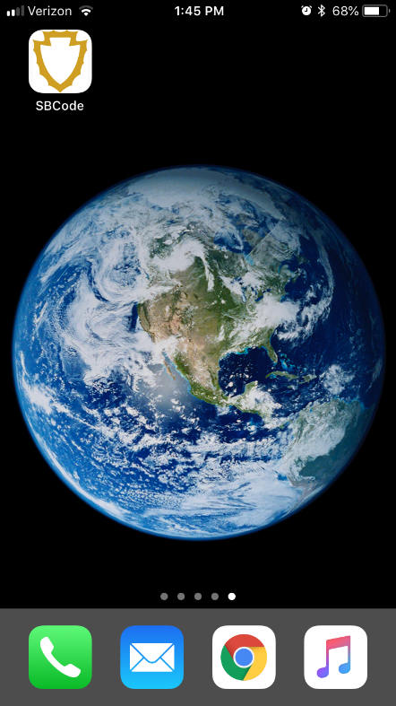

Click on “Submit a Request”
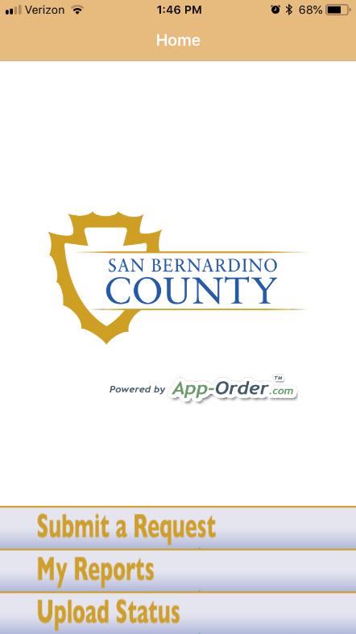

Now choose whichever issue it is that you would like to report. For this example, I clicked on “Illegal Dumping”
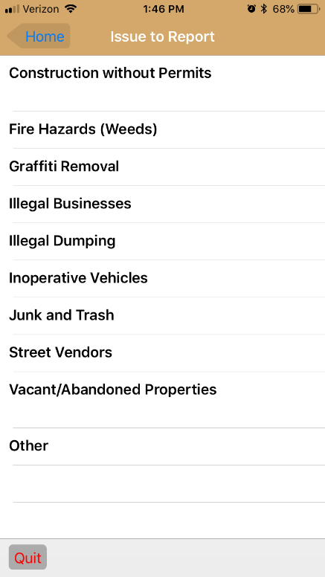

I chose “Vacant Lot”
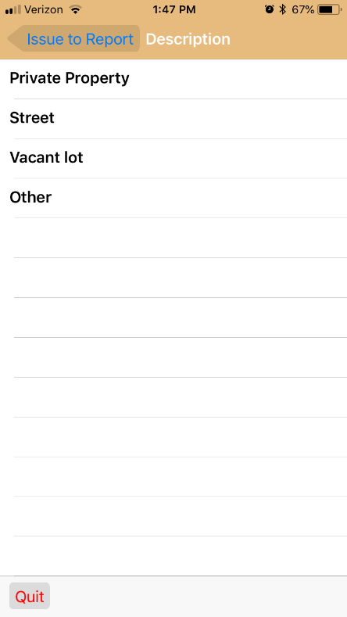

If there are any Hazardous Materials, click on the circle as shown on this photo.
Along the bottom you will see a camera icon and a photo icon. If you haven’t yet taken a photo of the issue you are reporting, please click on the camera and take a photo. If you previously took a photo, click on the photo icon and choose the photo from those saved on your device.
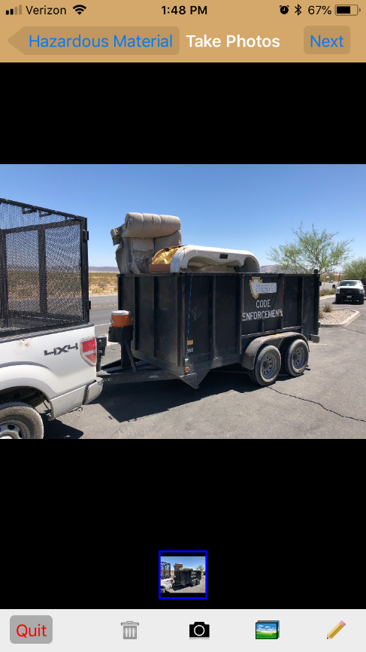
Add any other necessary information

Now you add the location/address of the issue that you are reporting.
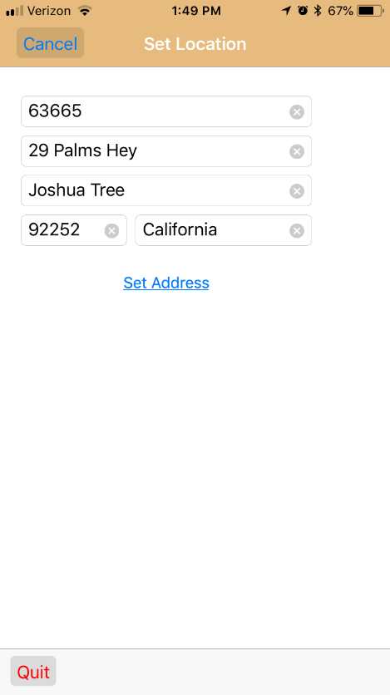
The app can also report your location which is handy if you don’t know an address to report…
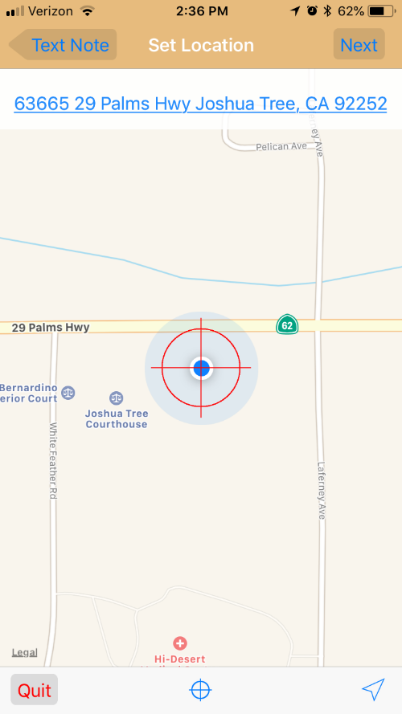
Now enter your information
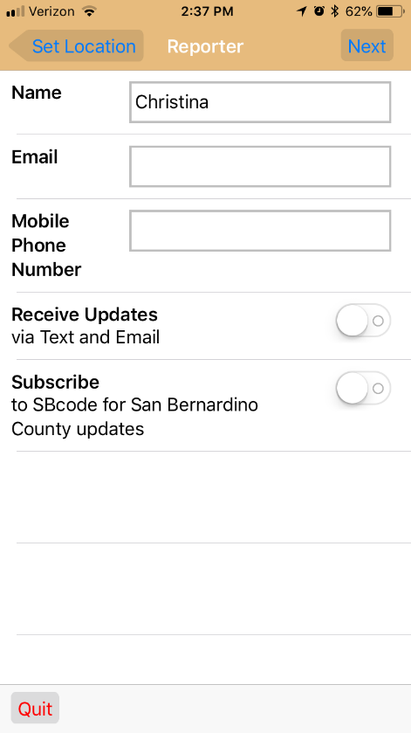
And the final step is reviewing the information you have already entered and then click “Submit” at the top.
